Accessibility Checklist with QM Alignment
8.1: Course navigation facilitates ease of use (3).
8.2: Information is provided about the accessibility of all technologies required in the course (3).
8.3: The course provides alternative means of access to course materials in formats that meet the needs of diverse learners (2).
8.4: The Course design facilitates readability (2).
8.5: Course multimedia facilitate ease of use (2).

Navigation
Content | QM | Yes | No | Notes
Instructional materials, tools, media, etc. are easy to locate. | 8.1
Course pages, folders, icons, links etc. are labeled with meaningful names/text. | 8.1
Tables constructed using correct/appropriate column and row headings/designations. | 8.1
Heading styles are used to indicate hierarchy. | 8.1

Accessibility Statements
Content | QM | Yes | No | Notes
Links to accessibility statements for all resources including, but not limited to, learning management system (Bb), publisher sites, 3rd party resources/software, and interactive modules or conferencing tools. | 8.2
Links to College disability support services provided. | 8.2

Text (BB content and Word or PowerPoint documents)
Content | QM | Yes | No | Notes
Basic readable font (Arial, Verdana, Tahoma). | 8.4
Good contrast (dark colors on light background – preferably black on white). | 8.4
Use one font throughout (mixing fonts can become confusing or distracting). | 8.4
Font size should be 12 or 14 point (not too small or too large). | 8.4
Use formatting options/styles instead of larger &/or bolded text. | 8.4

Content | QM | Yes | No | Notes
Use “Paragraph>>Heading” in BB  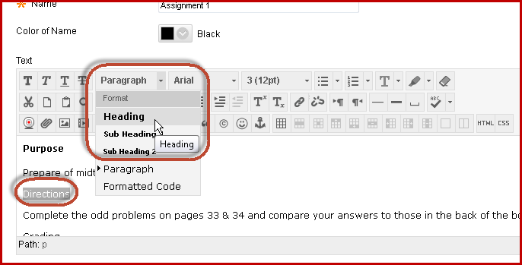  Use “Home: Heading 1” in Word | 8.1
Avoid using all CAPS, bold, italics and underlining for emphasis except where necessary. Remember to use the ribbon when in Word. | 8.3  8.4
Select colors carefully (not too bright or unusual). | 8.4
Avoid using color as only designation (not “all blue assignments are due on Tuesday”). | 8.3
Tables constructed using correct/appropriate column and row headings/designations. | 8.1  8.3
Numbered/lettered lists preferred when order/steps are important. Bulleted lists preferred when listing items when order/steps are not important. | 8.3
Simple, easily understood language. | 8.4

Links
Content | QM | Yes | No | Notes
Meaningful text description used as link (“Northern Virginia Community College” instead of “Click here”). | 8.1
Open in new window preferred with notation in link description (example: Review the Department of Education website (opens in new window).). | 8.1

Audio
Content | QM | Yes | No | Notes
Audio quality is clear. | 8.5
Size/length of the file is appropriate & easily downloaded. | 8.3
A written transcript is provided. | 8.3  8.5
Audio player compatible for multiple platforms (such as iTunes, MP3, Windows Media Player, etc.). | 8.5

Video
Content | QM | Yes | No | Notes
Video image is clear. | 8.5
Audio quality is clear. | 8.5
Size/length of the file is appropriate & easily downloaded. | 8.5

Content | QM | Yes | No | Notes
Video is closed captioned with visual context cues where appropriate. | 8.3  8.3  8.5
Video and captioning are accurate and synced. | 8.3  8.5
Video player is compatible for multiple platforms (such as Quicktime, RealPlayer, MP4, Windows Media Player, etc.). | 8.5

Images
Content | QM | Yes | No | Notes
Images are clear. | 8.5
Animated images are used only when supporting course content. | 8.5
Flashing/blinking images are avoided. | 8.5
Alt-text &/or long descriptions are provided. | 8.3  8.5
Null alt-text is used for images that are not necessary for instruction. | 8.3  8.5
Image files load quickly and easily. | 8.5

PDF files
Content | QM | Yes | No | Notes
Original document was accessible before saving as PDF. | 8.3
Document converted to PDF not scanned and saved as PDF (is actually an image rather than a readable PDF). | 8.3

Notes:
- Exam questions must follow the same accessibility guidelines as listed above.
- Use text/links rather than buttons for navigation in Blackboard.
Use 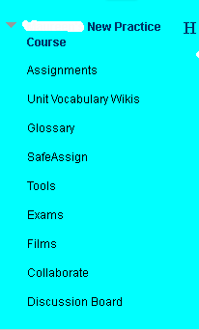 NOT 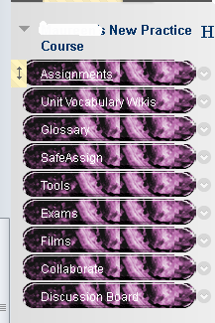 or 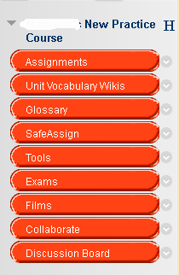
- Screen readers will read acronyms as one word so use Department of Justice instead of DOJ.
- All resources – publisher sites, 3rd party resources/software, interactive modules, conferencing tools SoftChalk, popular movies, etc. – must be accessible for all students.

